*Florida International University*

*School of Computing and Information Sciences*

CIS 4911 - Senior Capstone Project

Software Engineering Focus

Feature Document

User Story #955

**Team Member:**

Daniel Lopez

**Product Owner(s)**:

Mohsen Taheri

**Mentor(s)**:

Mohsen Taheri

**Instructor**: Masoud Sadjadi

**User Story** Testing and modifying faculty project proposal process

**Description**

As a developer, i would like to test and modify the process of proposing a project by a faculty, so that i know it works well.

**Acceptance Criteria**

1. <http://vip.fiu.edu/#/project-proposal> must work well.

**Use Case**

1. **Faculty can propose project**

**Use Case Diagram**

N/A Since this is doing quality assurance on a previously developed feature. See the original feature document made by the former developers of the feature.

**Sequence Diagram**

N/A Since this is doing quality assurance on a previously developed feature. See the original feature document made by the former developers of the feature.

**Class Diagram**

N/A Since this is doing quality assurance on a previously developed feature. See the original feature document made by the former developers of the feature.

**Unit Test & Integration Test**

* **Test Case 1**
  + **Purpose:** Test that a project proposal submission stores the project proposal submission in the database. Sets the status to pending.
  + **Precondition:** Valid values are put in the project proposal form.
  + **Expected Result:** A successful submission message is posted when submitted. Database does store the submitted project proposal.
  + **Actual Result:** Same as expected.
  + **Status: PASS**
* **Test Case 2**
  + **Purpose:** Test that a project proposal does not submit when information is invalid.
  + **Precondition:** Invalid values are put in the project proposal form.
  + **Expected Result:** An unsuccessful submission message is posted when submitted. Database doesn’t store the submitted project proposal.
  + **Actual Result:** Same as expected.
  + **Status: PASS**

**Visual User Guide**

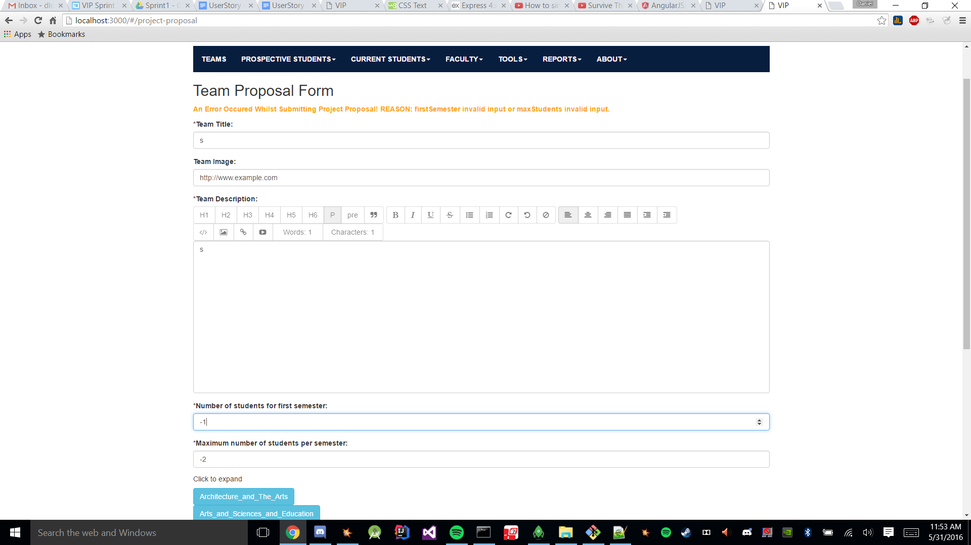

*Figure 1. Invalid Submission*

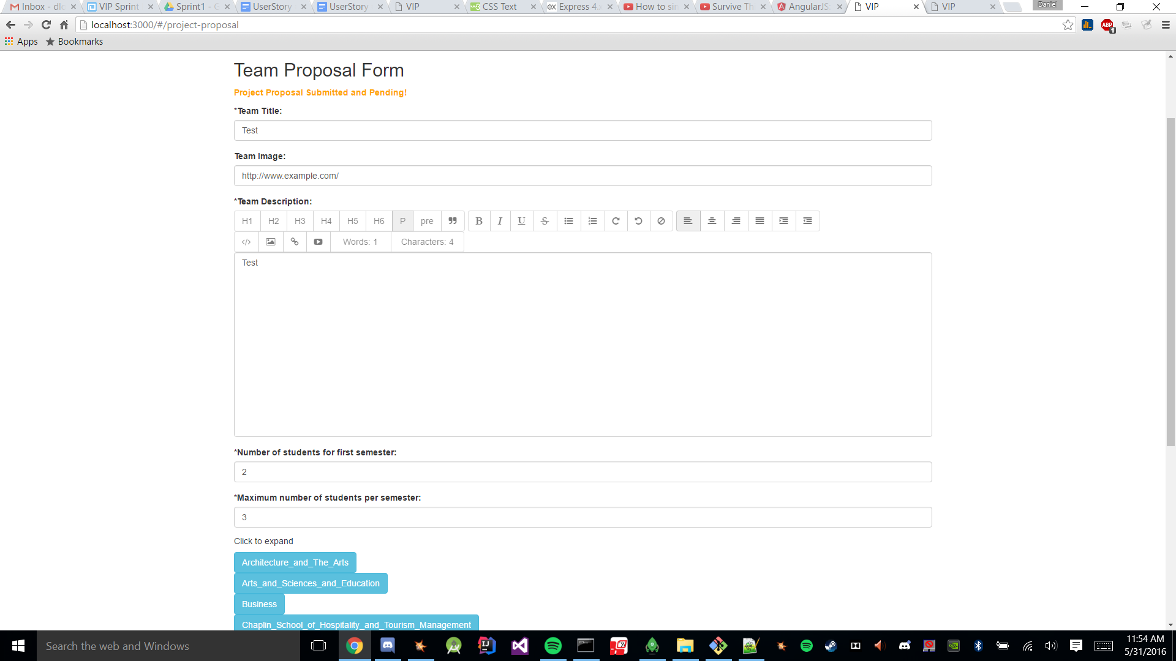

*Figure 2. Valid Submission*